Post Arcana / Enemies

Architecture/Design Document

**Table of Contents**

1. Introduction

2. Design Goals

3. System Architecture

4. Mid Level Design

5. Detailed Class Design

6. Process View

7. Use Case View

**Change History**

**Version:** 0.1

**Modifier:** Colin Brandow

**Date:** 03/12/2022

**Changes:** Design Document Created

**Version:** 0.2

**Modifier:** Colin Brandow

**Date:** 03/17/2022

**Changes:** System Architecture and Detailed Class Design

**Version:** 0.3

**Modifier:** Colin Brandow

**Date:** 03/18/2022

**Changes:** Document completed

1. Introduction

This document describes the design and architecture of Post Arcana by the Hex Decimals. Post Arcana is a single player open world RPG, set in a post apocalyptic small Canadian town after the introduction of magic to the real world.

The purpose of this document is to define the architecture and design of the enemy systemin a manner that assists the interests of all major stakeholders. The major stakeholders and their interests are as follows:

* Developers: A design that is easy to implement that minimizes complexity
* Project Manager: A design that can be easily divided among the skills of the programmers
* Maintenance Programmers: A design that can be improved upon easily

1. Design Goals

The design goals for the Enemy system are as follows:

* The design must minimize complexity
* The design must allow for multiple enemy behaviors that are easy to implement
* The design should be easy to amend and balance

1. System Architecture

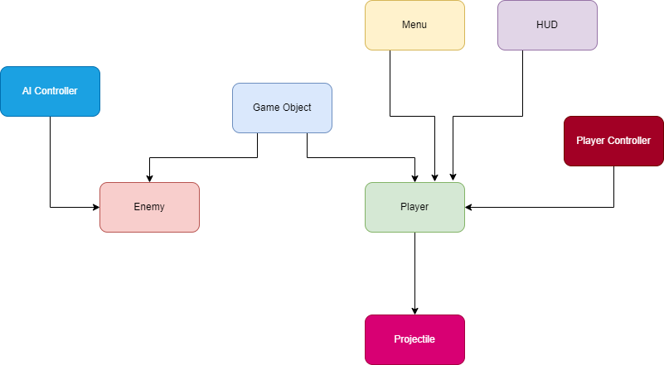

* GameObject: Base class for the game entities (Players and enemies). Stores abstract and concrete stats.
* Enemy: The class used for enemy-only stats and components
* AI Controller: Moves and controls the enemies
* Player: The class used for player-only stats and components
* Player Controller: Receives player input and controls the player
* Projectile: Is launchd by the player, and deals damage to Game Objects
* Menu: Places a UI element on the screen given a specific input
* HUD: Shows the player important stats

1. Mid Level Design

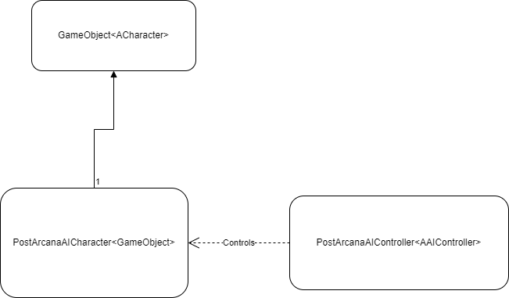

1. Detailed Class Design

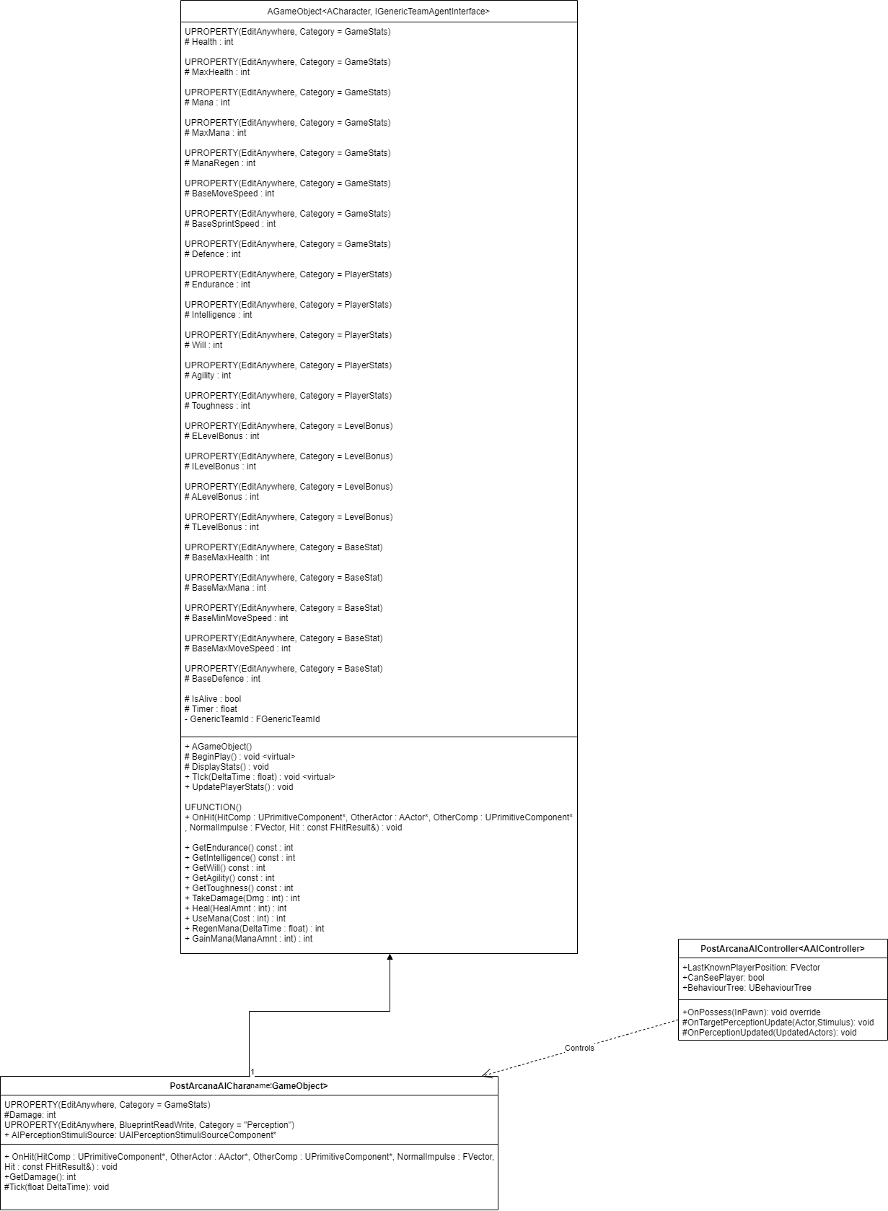

1. Process View

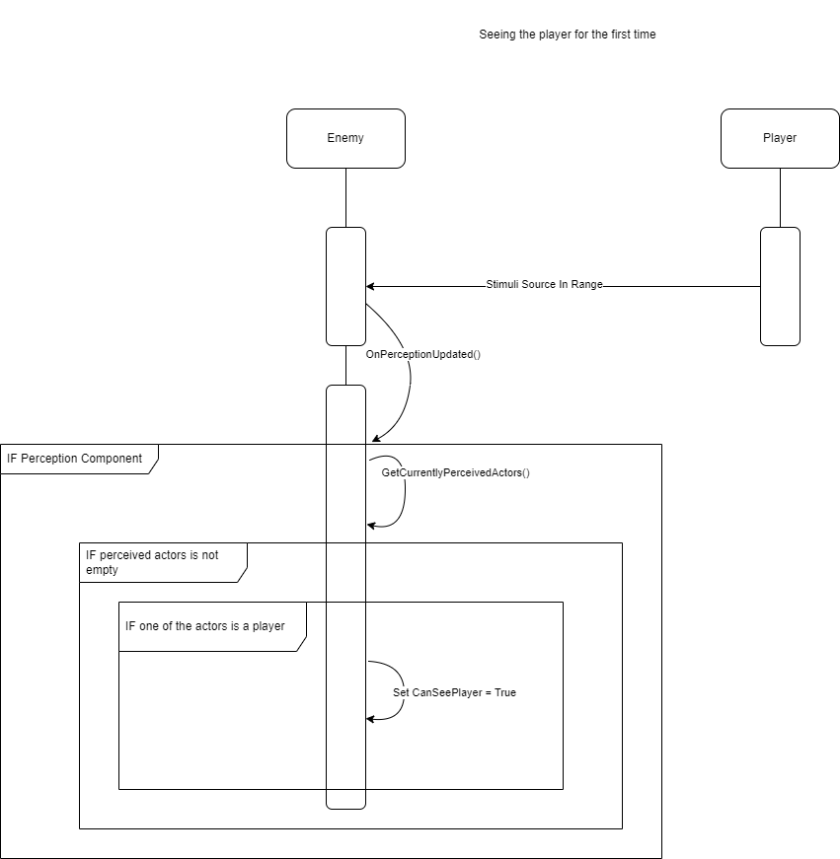

The first time an enemy senses the player using its sensing component it will first call its OnPerceptionUpdated() as its perception has been updated. Then if the enemy still has a perception component, it will call GetCurrentlyPercievedActors() to generate a list of actors it can perceive, using its perception component. Then if the perceived actors list isn’t empty and one of the actors can be cast to player, it will change CanSeePlayer to true. This information can then be passed to a behavior tree for use.

1. Use Case View

The enemy can by modified in two major ways. The first is it’s stats to change it’s health, damage or speed. To change this see the Post Arcana/Stat System design document, section 7.

To modify an enemy’s behaviour it is best to first duplicate some of the already existing Blueprints. Specifically, a developer would need a new AICharacter Blueprint and a new AIController Blueprint, as highlighted below :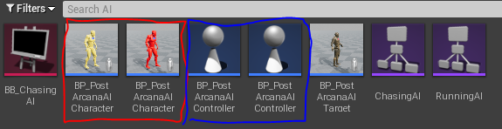

Next, the developer should set the new AICharacter’s AI Controller to their newly created AI controller, under the pawn heading, subheading AIController class:

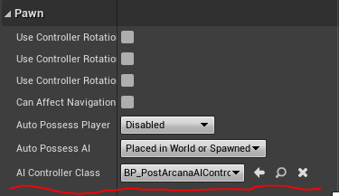

Then to change the behavior all a developer would need to do is choose or create a a behaviour tree, then set it in the AIController class under the Post Arcana AIController heading:

